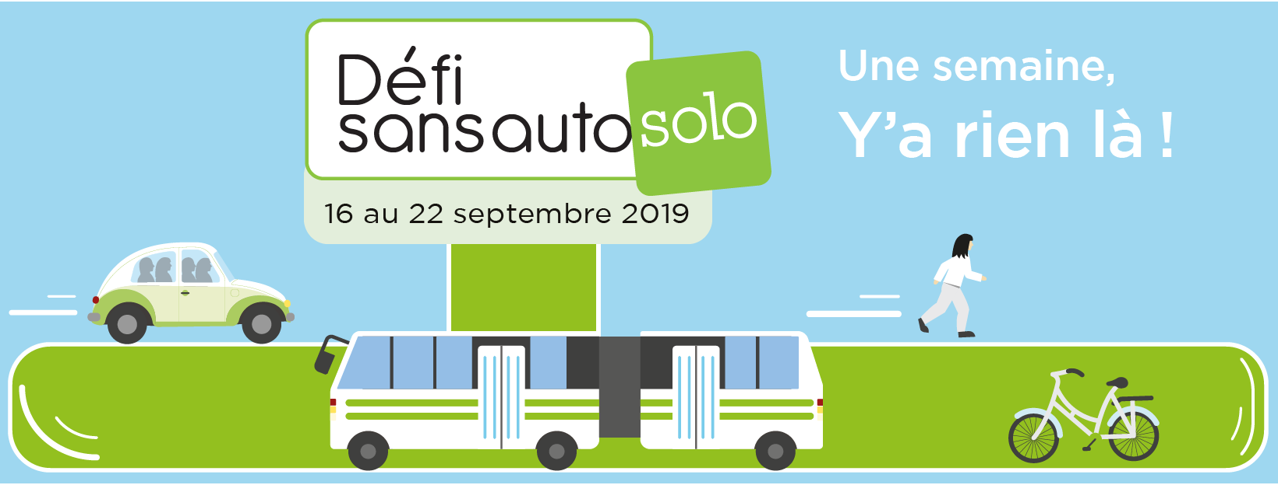
Hi,

From September 16th to 22nd, (your organisation) is participating in the Défi sans auto solo, a no solo driving challenge organized by the Association des Centres de gestion des déplacements du Québec.

On that week, we encourage you to commute to work by bus, bicycle, walking, carpooling or any other means of sustainable transport.

You could win one of many prizes, including a vacation offered by Transat or a train getaways with VIA Rail. In addition, by participating in large numbers, you could help (your organisation) win the Défi sans auto solo.
Participate in the Challenge in two simple steps!

Step 1 – Register

Create your account at https://defisansautosolo.greenplay.social/register/user
Select your organization from the drop-down menu.

Step 2 – Record your trips

Log in to your account here: https://defisansautosolo.greenplay.social/log_in

Record your moves in one of two ways:
• Automatically – by connecting your account to your mobile device (collection of your data)
• Manually – by entering your movements (mode and distance) in your account

Participate in large numbers!
One week, there's nothing there!

